Instructions for Project file:

1. Since review_time column was in unix format, I have converted it in Date format in excel instead of python as it was easier. Please use below instructions to add a new converted column in excel file:
   1. Add a new column named “Converted review_time”
   2. Add an excel formula in that column as: =(M2/86400)+DATE(1970,1,1)
   3. Drag result to the end row
   4. Change the formatting for the column to Date by right click > Format Cells>

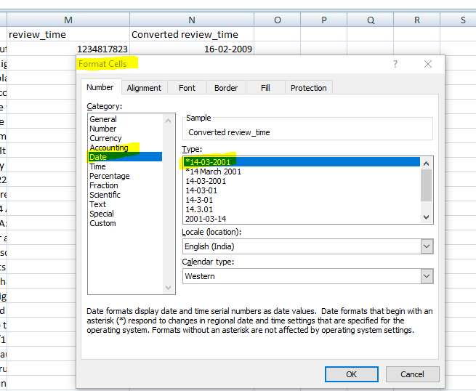

**Note: I’m also providing the link for my converted dataset here as Github doesn’t allow file for more than 25 mb. Please use below link in case you want to directly use the updated excel data file instead of converting:** [**https://drive.google.com/file/d/1xGvubkvSh39-HZl021TZxFcLUUh4oN-U/view?usp=sharing**](https://drive.google.com/file/d/1xGvubkvSh39-HZl021TZxFcLUUh4oN-U/view?usp=sharing)

**Also, please note that I have rename the dataset excel as: BeerDataScienceProject33**

1. Please use below github repository for Jupiter notebook python file file: <https://github.com/darshan1108/Project-Submission>
2. I have included summary of all findings and related writeup the Jupiter notebook file, hope it will be helpful.
3. The sentiment analysis codes might take 2 to 3 hours to run as the dataset is too large, please plan accordingly.

**Thanks!**